Format of Curriculum Vitae (CV) / Résumé
www.jshpgc.ac.in

Title | Prof./Dr./Mr./Ms. |  |  | First Name |  | BABLOO |  |  | Last Name |  |  |  | SINGH |  |  | Photograph
Designation |  |  |  | ASSISTANT PROFESSOR |  |  |  |  |  |  |  |  |  |  |  | 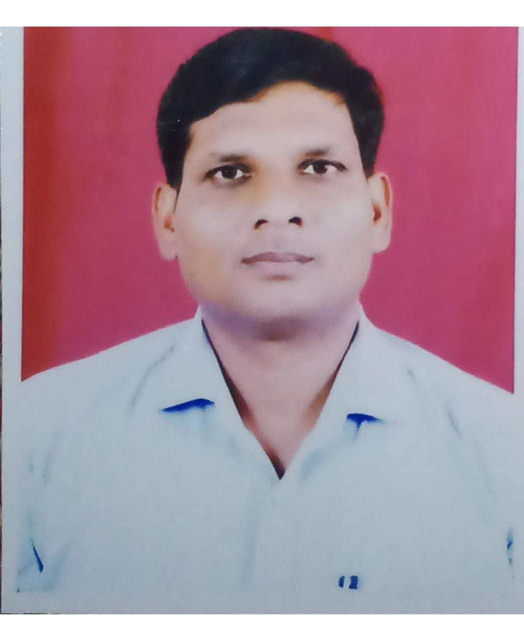
Department |  |  |  | HINDI
Address  (Campus) |  |  |  | 1245 BANK COLONY CHAMRI ROAD HAPUR UP 245101
(Residence)
Phone No
(Campus)
(Residence)
Mobile |  |  |  | 9412619392
Fax
Email |  |  |  | Bssingh2015@gmail.com
Web-Page
Educational Qualifications (Graduation Onwards)
Course/Degree |  |  |  | Institution |  |  |  |  |  | Year |  |  |  |  | Details/Thesis Topic/Subjects
GRADUATION |  |  |  | CCSU MEERUT |  |  |  |  |  | 1999 |  |  |  |  | HINDI,SANS.ECO.
PG |  |  |  | AS ABOVE |  |  |  |  |  | 2001 |  |  |  |  | HINDI
Career Profile
Organization / Institution |  |  |  |  | Designation |  |  |  |  |  | Duration |  |  |  |  |  | Role
JS HINDUPG COLLEGE AMROHA |  |  |  |  | ASSISTANT PROFESSOR |  |  |  |  |  | 11-08-2010 TO TILL NOW
Research Interests / Specialization
LINGUISTICS
Teaching Experience (Subjects/Courses Taught)
12 YEARS HINDI ( UG&PG)
Honors & Awards
Publications /Academic Activities (Numbers Only)
Books & Monographs (Single Author) |  |  | Research Papers Published in International Journals |  |  |  |  | Papers Presented in Seminars/  Conferences |  |  |  |  |  | Seminars/ Conferences Organized |  |  |  |  | Research Projects (Completed)
Books (Co-authored) |  |  | Research Papers Published in Other Journals |  |  |  |  | Seminar/ Conferences Attended |  |  |  |  |  | Workshops Organized |  |  |  |  | Research Projects (Ongoing)
Books (Edited) |  |  | Articles Published in Popular Fora, e.g., Websites, Blogs, Newspapers, Magazines etc. |  |  |  |  | Sessions Chaired in Seminars/ Conferences |  |  |  |  |  | Membership of Academic/ Professional Bodies |  |  |  |  | Foreign Countries Visited for Academic Assignments
Chapters in Edited Books
 |  |  |  |  |  |  |  | Resource Lectures Delivered

Details of Publications /Academic Activities (2010 Onwards)
(a) Books / Monographs
Year of Publication | Title | Publisher | ISBN | Co-Author (s)  (if any)

(b) Papers Published in Indexed/ Peer Reviewed Journals
Year of Publication | Title | Journal | ISSN/ Indexing | Co-Author (s)  (if any)

(c) Articles

(d) Seminar/Conference Presentations

(e) Resource Lectures Delivered

(f) Seminars/Conferences/Workshops Organized

(g) Public Service / University Service / Consulting Activity

(h) Memberships of Academic/Professional Bodies

Projects (With Title, Year, Grants, Funding Agency and Collaborations)
छात्रों पर टेलिविज़न और इंटरनेट का बढ़ता प्रभाव :उत्तर प्रदेश के विशेष संदर्भ में एक सामाजिक अध्ययन 2021 500000 ICSSR
Administrative Positions/Assignments Held
Academic Foreign Visits
Any Other Details

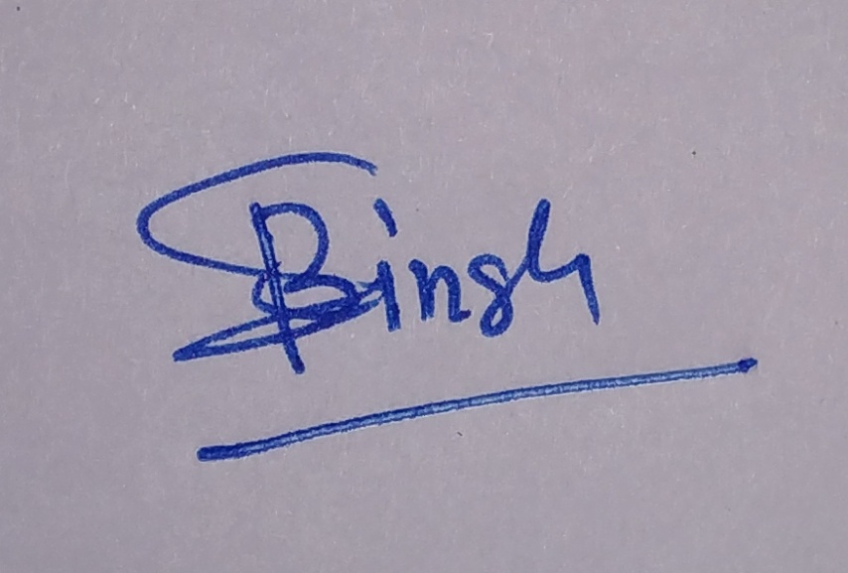

Signature of Faculty Member

