Format of Curriculum Vitae (CV) / Résumé
www.jshpgc.ac.in

Title | Prof./Dr./Mr./Ms. |  |  | First Name |  | RAJEEV |  |  | Last Name |  |  |  | KUMAR |  |  | Photograph
Designation |  |  |  | ASSISTANT PROFESSOR |  |  |  |  |  |  |  |  |  |  |  | 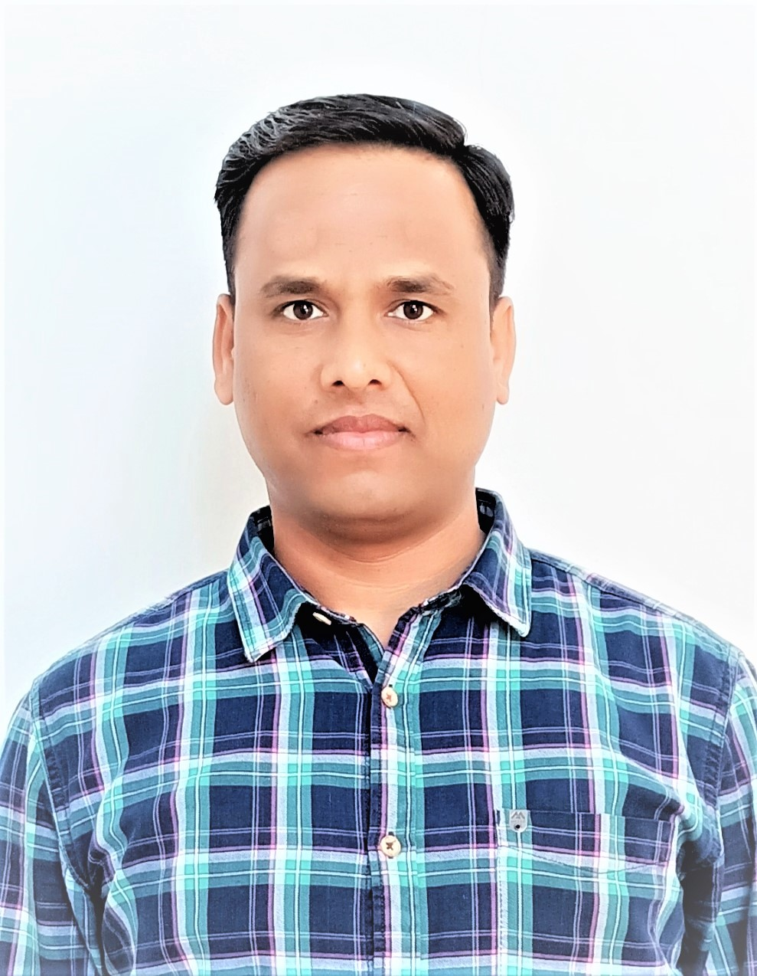
Department |  |  |  | HINDI
Address  (Campus) |  |  |  | VAISHALI NAGAR PHASE- 2 GAS GODAM ROAD CHANDAUSI DISST-. SAMBHAL, PIN- 244412
(Residence)
Phone No  (Campus) |  |  |  | -
(Residence)
Mobile |  |  |  | 9412553035
Fax
Email |  |  |  | rk268725@gmail.com
Web-Page
Educational Qualifications (Graduation Onwards)
Course/Degree |  |  |  | Institution |  |  |  |  |  | Year |  |  |  |  | Details/Thesis Topic/Subjects
B.A. |  |  |  | J.S. HINDU P.G. COLLEGE AMROHA |  |  |  |  |  | 2007 |  |  |  |  | HINDI,SOCIOLOGY
M.A. |  |  |  | AS ABOVE |  |  |  |  |  | 2012 |  |  |  |  | HINDI
Career Profile
Organization / Institution |  |  |  |  | Designation |  |  |  |  |  | Duration |  |  |  |  |  | Role
J.S. HINDU P.G. COLLEGE AMROHA |  |  |  |  | ASSISTANT PROFESSOR |  |  |  |  |  | 01 JUNE 2022 TO TILL NOW |  |  |  |  |  | ASSISTANT PROFESSOR
Research Interests / Specialization
-
Teaching Experience (Subjects/Courses Taught)
1 YEAR 10 MONTHS ( HINDI LITRATURE – B.A.- Ist, IInd, IIIrd , IVth, Vth & VIth SEMESTER/ M.A.- Ist, IInd, & IIIrd SEMESTER)
Honors & Awards
Publications /Academic Activities (Numbers Only)
Books & Monographs (Single Author) nil |  | - | Research Papers Published in International Journals -nil |  |  |  | - | Papers Presented in Seminars/  Conferences - 02 |  |  |  | - |  | Seminars/ Conferences Organized--nil |  |  |  | - | Research Projects (Completed)--nil | -
Books (Co-authored) |  |  | Research Papers Published in Other Journals-- 02 |  |  |  |  | Seminar/ Conferences Attended--05 |  |  |  |  |  | Workshops Organized  --01 |  |  |  |  | Research Projects (Ongoing)--nil
Books (Edited) |  |  | Articles Published in Popular Fora, e.g., Websites, Blogs, Newspapers, --nilMagazines etc. |  |  |  |  | Sessions Chaired in Seminars/ Conferences |  |  |  |  |  | Membership of Academic/ Professional Bodies--nil |  |  |  |  | Foreign Countries Visited for Academic Assignments--nil--nil
Chapters in Edited Books-- 02
 |  |  |  |  |  |  |  | Resource --nilnilLectures Delivered

Details of Publications /Academic Activities (2010 Onwards)
(a) Books / Monographs
Year of Publication | Title | Publisher | ISBN | Co-Author (s)  (if any)

(b) Papers Published in Indexed/ Peer Reviewed Journals
Year of Publication | Title | Journal | ISSN/ Indexing | Co-Author (s)  (if any)
2023 | हिन्दी के वैश्विक विस्तार में मीडिया का योगदान | बोहल शोध मंजूषा | 2395-7115 | नहीं
2023 | साहित्यिक अनुसंधान स्वरूप एवं प्रकार – संक्षिप्त दृष्टि | गीन शोध संगम | 2321-2837 | नहीं

(c) Articles
02
(d) Seminar/Conference Presentations
05
(e) Resource Lectures Delivered

(f) Seminars/Conferences/Workshops Organized
01
(g) Public Service / University Service / Consulting Activity

(h) Memberships of Academic/Professional Bodies

Projects (With Title, Year, Grants, Funding Agency and Collaborations)
Administrative Positions/Assignments Held
Academic Foreign Visits
Any Other Details



Signature of Faculty Member

